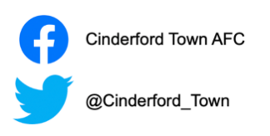

Friends of Cinderford Town Football Club Membership Form
*Official Use Only*
Date: ………../…………/………….
Membership No. ……………..
Suffix: …………………..
First Name/s: ………………………………… Surname: ……………………...
Postal Address: …………………………………………………………………..
………………………………………………………………………………………Postal Code: …………………… Contact Number: …………………………
Email Address: …………………………………………………………………..
Date of Birth: ……………../……………/………….

Membership (Please Tick)
- Junior Supporter (Up to 16 Years of Age) - £5 per season
- Adult Supporter - £15 per season
*Official Use Only*

Applicant Signature Club Official Signature

………………………. ………………………….
Date: ………../………../………..

Please return completed electronic forms to grahambevan1@hotmail.co.uk
Membership Fee can be paid in cash at the Causeway along with a completed membership form or via BACS
Account Number: 81475134 Sort Code: 40-17-24

